Check link: <https://market.binamon.org/genesis>

1. Remove Header Menu
2. Change Navbar Menu
3. 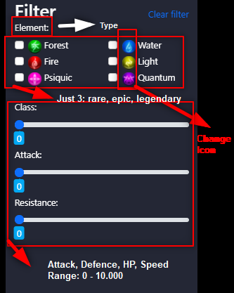Custom filter menu

1. Custom Header of Content

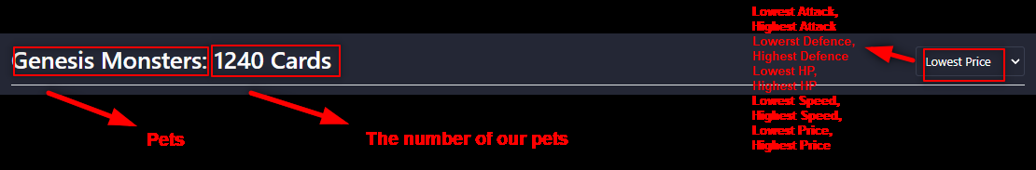

**The number is 12.**

1. 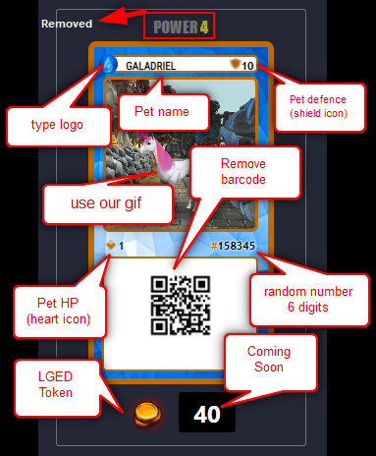Card Custom Design In Pet Menu

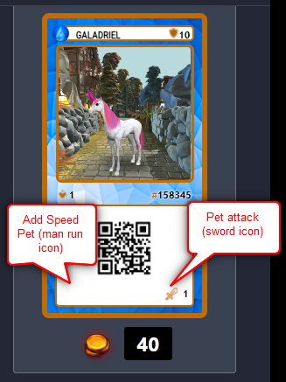

This picture is just example:

